TECH1015 Multimedia 1
Coursework 2
Daniela Costache
P2599859

Peer Feedback
For this site I have created a survey, which 5 people answered. The site has been viewed by each one of them that have answered the questionnaire.

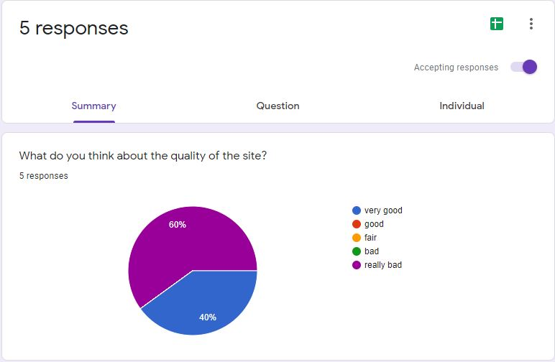
Fig. 1
The answers were honest as the site has not meet the right standard.
Code Validation
HTML Validation
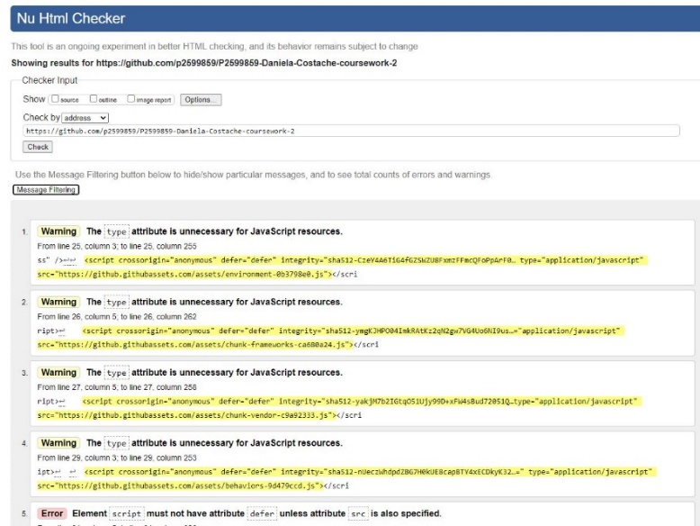
Fig. 2
The errors were not that easy to fix, as they have been a lot of warnings and a couple of errors.

CSS Validation
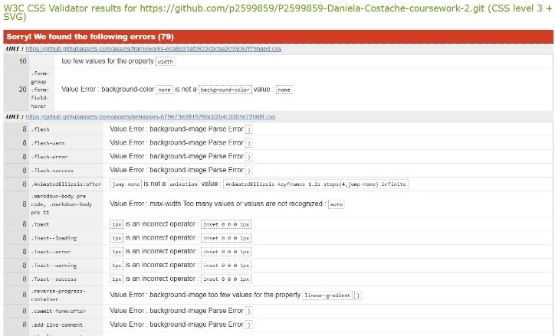
Fig. 3
As we see in this picture there are a lot of errors that the site has. Which some of them can be fixed easily. But most of them have been found kind of complicated to solve out.

Lighthouse Report
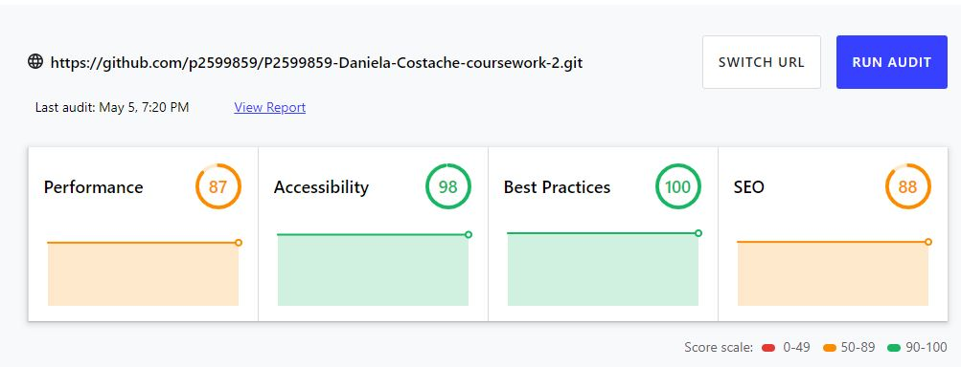
Fig. 4
There have been found some minor issues that can be improved, but this is still a fair result.
Cross-Browser Testing
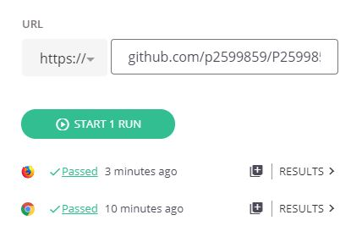
Fig. 5
The site has been responded well to these two browsers.

Conclusion
In conclusion there are several things that can be improve on this website.
Such as the way of how the things are put on the pages, the images could have been put on, not just links to them. But the website still has some essential information on, that are revealing the right purpose of the site from the beginning.

Appendices
• Image 1 - https://pin.it/3kAdR2g

• Image 2 - https://variety.com/2020/film/news/f9-release-date-delay-1234791197/

• Trailer - https://m.youtube.com/watch?v=_hrguJlsZ90

Second page:
• Image 1 and 2 - https://www.bing.com/search?FORM=BMSBRL&q=f9&PC=BM03
(screenshots from google)
Third page:
• Image 1 - https://www.bing.com/search?q=f9+release+date+&qs=n&form=QBRE&msbsrank=5_5__0&sp=-1&pq=f9+release+date+&sc=5-16&sk=&cvid=821B74A882324DE09608D366F10E7603

• Image 2 - https://www.timeanddate.com/countdown/generic?iso=20210519T00&p0=136&msg=F9&font=cursive

